1. INTRODUCTION

1.1 OBJECTIVE
The main objective of the application is to build a “Notification Center” by using the Bluetooth Beacons, which pushes the notifications related to our college updates to our smart phones through Bluetooth.

1.2 SCOPE
“A Bluetooth Beacon notification sender system” notifies the information about college related details. The updated college information is send to the mobile phones as a notification type suggestion using Bluetooth Beacons technology.
All the details regarding the events, event details, event date, event venue, event time, exam schedules, time tables, departmental notifications, administration and exam cell notifications, any kind of college updates.

1.3 Purpose
“A Bluetooth Beacon notification sender system” maintains the college details such as exams, timetables, events, activities, fees details, placement details etc. The reports and all other information that are to be kept in a database and also to be retrieved easily when the notification received by the user.

This completely replaces the college notice board because all the notices can be updated to the data base and can be notified to all the students by saving the time, energy, resources. In this way admin can directly reach to the students through this “college event notifier ”.

2. SYSTEM ANALYSIS

2.1 EXISTING SYSTEM
In previous scenario students used to check the notice boards at each department to know the college updates or by receiving E-mail messages or sms messages.

2.1.1 LIMITATIONS OF EXISTING SYSTEM
- It consumes time
- Cost
- There is no single platform for notifications.

2.2 PROPOSED SYSTEM
This proposed system is a mobile based application which provides notifications when we reach the range of the device. This provides the updates of the any area.

This can be customized to an area, According to usage. Our application is mobile application which notifies the user or student on schedules, time-table, seminars, presentations, exams.

And admin for updating the database for notifications..

2.2.1 ADVANTAGES OF PROPOSED SYSTEM
.
- This saves time of the student and also faculty.
- This application is specified to certain area.
- This also saves energy and resources.

2.3 FEASABILITY STUDY
Many Feasibility study are disillusioning for both users, analysts. First, the study often supposes that feasibility document is being prepared; the analyst is in a position to evaluate solution. Second, most studies tend to overlook the confusion inherent in the system development- the constraints and the assumed attribute. If the Feasibility study is to serve as decision document for a project, it must answer 3 key questions:

Three key Considerations involved in the feasibility analysis:
- Economic
- Technical
- Behavioral

Economic Feasibility
This application on the client side has been developed using Voice XML which is open source software. The hardware required is telephone, which is not expensive. Hence the application is economically feasible.Technical Feasibility

As the application has been developed using JSP and the back end as oracle which utilizes minimum resources of the personal computer, this project is Technical Feasible. Here we work on my eclipse which is very comfortable even for the naive users.

Technical Feasibility
As the application has been developed using JSP and the back end as oracle which utilizes minimum resources of the personal computer, this project is Technical Feasible. Here we work on my eclipse which is very comfortable even for the naive users.

Behavioral Feasibility
This project has been implemented using VOXEO and it satisfies all conditions and norms of the organization and the users.

3. SYSTEM REQUIREMENT SPECIFICATION

The Main purpose for preparing this document is to give a general insight to the analysis and requirements of the existing system or situation and for determining the Operating characteristic of the System.Requirements specifying set of features that the system must have. A functional requirements is a specification of a function that the system must support, where as a nonfunctional requirements is a constraint on the operation of the system that is not related directly to function.

Nonfunctional requirements may include using specific hardware platform for the system, security requirements, how the system should deal with failure and faults and how to provide backward capability with an old system that the client is unwilling to work.

3.1 FUNCTIONAL REQUIREMENTS
In this SRS we will be dealing with the
- Provisioning
- Functioning
- Queries
- Alerts
- Reports

Modules
- Events Notification Management.
- Exam Notification Management.
- Administration notification Management.
- Placement Notifications Management.

Exam notification management

- Provisions:
- EXAMID
- EXAMNAME
- EXAMDETAILS
- EXAMDATE
- UPDATEDATE

- Functionality:
Examination alerts:
These are updated by the admin regarding the exam schedule, time of exam, subject and room number.

- Alerts:
Alerts on exam type, name, date and time of exam.

Events notification management:
- Provisions:
EVENT
- EVENT_ID
- EVENT_CATEGORY.

EVENT SUBCATERGORY
- EVENT_NAME
- EVENT_TIME
- EVENT_PALCE
- EVENT_DETAILS

- Functionality:
- Technical events:
all the details like technical events like seminars, workshops are to be entered by the database admin.
- Cultural events: all the cultural events like fests, annual day, club events can be updated by the admin.
- Alerts:
Alerts on Event name, time, place, details.

- Queries:
- What is the category of event?
- What is the event name, event place, event details?

Administration management:
- Functionality:
Alerts of administration department updates like fee due, due date, examination fee details, scholarship notifications.

- Provisions:
ADMINISTRATION
- UPDATEID
- UPDATE_NAME
- UPDATE_INFO
- UPDATEDATE

- Alerts:
Alerts on updated details of administration.
- Queries:
- What is update?
- What are the update details?

Departmental notifications:
- Functionality:
This is updated by the departmental admin regarding the departmental notifications and notices like assignment

- Provision:
DEPARTMENT
- DEPTID
- DEPTNAME

DEPTUPDATE
- DEPTUPDATEID
- DEPTID
- DEPTNOTICE
- UPDATEDATE

- Alerts:
Alerts on departmental updates.
- Queries:
- What is the department?
- What is the department name?
- What is the department notice?

Placement notifications:
- Functionality:
This provides the notification updated by the placements admin, regarding placements drive, date, place and also training classes.

- Provisions:
PLACEMENTSDEPT
- PLACEMENTUPDATEID
- PLACEMENTUPDATENAME
- PLACEMENTUPDATEDETAILS
- Alerts:
Alerts on placements updates.

- Queries:
What is the placement?
What are placement details?

3.2 NON FUNCTIONAL REQUIREMENTS

3.2.1 Usability
The controls that are used in the content production management system are user friendly. The controls used by the users and administrators are easy to manage.

3.2.2 Reliability
The system should be accessible by only the respective admin who are working in that Travel Agencies. An authorized person will be responsible for the data and will maintain master date and parameters. The data accessing techniques kept are transparent to the end user. Data definition can be done only by the administrators and all the data storage should be up to date.

3.2.3 Performance
In order to get the high performance we need the server that requests at a time to process and also we need a high speed internet connection.

3.2.4 Supportability
This should be able to support any number of contents can be deployed to the particular zones. In similar at the same time administrator and users can proceed with their work.

3.3 SOFTWARE REQUIREMENTS
Client side
Technology : Android

Server side
Front End
Operating System : Windows
Tools : Eclipse Galileo, Juno
Technology : Java

Back End
Database : Oracle 10g
Server : Tomcat 6.0

3.4 HARDWARE REQUIREMENTS
Client side : Android Phone
Server Side:
Processor : Intel Pentium IV 2.66GHz
Hard disk : 40GB
Cache : 512KB
RAM : 1GB or more
Device :Bluetooth Beacon Low Energy 4.0

4. TECHNOLOGIES USED

INTRODUCTION TO JAVA

The Java programming language is a high-level language that can be characterized by all of the following buzzwords
    - Simple
    - Architecture neutral
    - Object oriented
    - Portable
    - Distributed
    - High performance
    - Interpreted
    - Multithreaded
    - Robust
    - Dynamic
    - Secure

With most programming languages, you either compile or interpret a program so that you can run it on your computer. The Java programming language is unusual in that a program is both compiled and interpreted. With the compiler, first you translate a program into an intermediate language called Java byte codes —the platform-independent codes interpreted by the interpreter on the Java platform. The interpreter parses and runs each Java byte code instruction on the computer. Compilation happens just once; interpretation occurs each time the program is executed. The following figure illustrates how this works.

You can think of Java byte codes as the machine code instructions for the Java Virtual Machine (Java VM). Every Java interpreter, whether it’s a development tool or a Web browser that can run applets, is an implementation of the Java VM. Java byte codes help make “write once, run anywhere” possible. You can compile your program into byte codes on any platform that has a Java compiler. The byte codes can then be run on any implementation of the Java VM. That means that as long as a computer has a Java VM, the same program written in the Java programming language can run on Windows 2000, a Solaris workstation, or on an iMac.

Features of Java
Security
Every time you that you download a “normal” program; you are risking a viral infection. Prior to Java, most users did not download executable programs frequently, and those who did scan the for viruses prior to execution. Most users still worried about the possibility of infecting their systems with a virus. In addition, another type of malicious program exists that must be guarded against. This type of program can gather private information, such as credit card numbers, bank account balances, and passwords. Java answers both of these concerns by providing a “firewall” between a networked application and computer. When you use a Java-compatible Web browser, you can safely download Java applets without fear of virus infection or malicious intent.

Portability
For programs to be dynamically downloaded to all the various types of platforms connected to the Internet, some means of generating portable executable code is needed .As you will see, the same mechanism that helps ensure security also helps create portability. Indeed, Java’s solution to these two problems is both elegant and efficient.

Simple
Java was designed to be easy for the Professional programmer to learn and to use effectively. If you are an experienced C++ programmer, learning Java will be even easier. Because Java inherits the C/C++ syntax and many of the object oriented features of C++. Most of the confusing concepts from C++ are either left out of Java or implemented in a cleaner, more approachable manner. In Java there are a small number of clearly defined ways to accomplish a given task.

Object-Oriented
Java was not designed to be source-code compatible with any other language. This allowed the Java team the freedom to design with a blank slate. One outcome of this was a clean usable, pragmatic approach to objects. The object model in Java is simple and easy to extend, while simple types, such as integers, are kept as high-performance non-objects.

Robust
The multi-platform environment of the Web places extraordinary demands on a program, because the program must execute reliably in a variety of systems. The ability to create robust programs was given a high priority in the design of Java. Java is strictly typed language; it checks your code at compile time and run time. Java virtually eliminates the problems of memory management and de-allocation, which is completely automatic. In a well-written Java program, all run time errors can –and should –be managed by your program.

The most common types of programs written in the Java programming language are applets and applications. If you’ve surfed the Web, you’re probably already familiar with applets. An applet is a program that adheres to certain conventions that allow it to run within a Java-enabled browser.

However, the Java programming language is not just for writing cute, entertaining applets for the Web. The general-purpose, high-level Java programming language is also a powerful software platform. Using the generous API, you can write many types of programs.

An application is a standalone program that runs directly on the Java platform. A special kind of application known as a server serves and supports clients on a network. Examples of servers are Web servers, proxy servers, mail servers, and print servers. Another specialized program is a Servlet. A Servlet can almost be thought of as an applet that runs on the server side. Java Servlets are a popular choice for building interactive web applications, replacing the use of CGI scripts. Servlets are similar to applets in that they are runtime extensions of applications. Instead of working in browsers, though, Servlets run within Java Web servers, configuring or tailoring the server.

Java has had a profound effect on the Internet. This is because; Java expands the Universe of objects that can move about freely in Cyberspace. In a network, two categories of objects are transmitted between the Server and the Personal computer. They are: Passive information and Dynamic active programs. The Dynamic, Self-executing programs cause serious problems in the areas of Security and probability. But, Java addresses those concerns and by doing so, has opened the door to an exciting new form of program called the Applet.

We can’t promise you fame, fortune, or even a job if you learn the Java programming language. Still, it is likely to make your programs better and requires less effort than other languages. We believe that Java technology will help you do the following:

Get started quickly Although the Java programming language is a powerful object-oriented language, it’s easy to learn, especially for programmers already familiar with C or C++.

Write less code Comparisons of program metrics (class counts, method counts, and so on) suggest that a program written in the Java programming language can be four times smaller than the same program in C++.

Write better code The Java programming language encourages good coding practices, and its garbage collection helps you avoid memory leaks. Its object orientation, its JavaBeans component architecture, and its wide-ranging, easily extendible API let you reuse other people’s tested code and introduce fewer bugs.

Develop programs more quickly Your development time may be as much as twice as fast versus writing the same program in C++. Why? You write fewer lines of code and it is a simpler programming language than C++.

Avoid platform dependencies with 100% Pure Java You can keep your program portable by avoiding the use of libraries written in other languages. The 100% Pure Java Product Certification Program has a repository of historical process manuals, white papers, brochures, and similar materials online.

Write once, run anywhere Because 100% Pure Java programs are compiled into machine-independent byte codes, they run consistently on any Java platform.
Java Virtual Machine ( JVM )

It is the heart of entire java program execution process. It is responsible for taking the .class file and converting each byte code instruction into the machine language instruction that can be executed by the microprocessor.

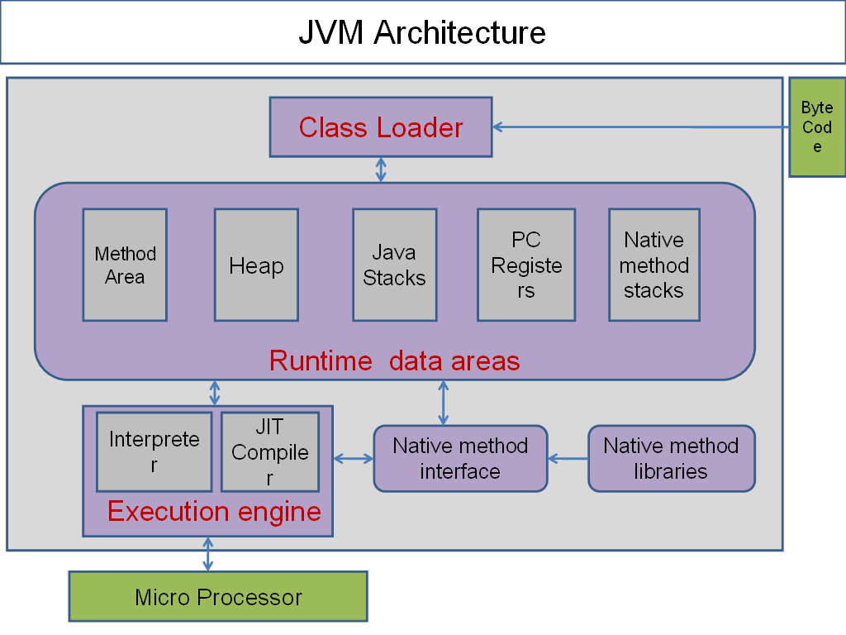

Class Loader
It loads the .class file into memory. Then it verifies whether all byte code instructions are proper or not. If it finds any instruction suspicious, then the execution is rejected immediately. If the byte instructions are proper, then it allocates necessary memory to execute the program.

Run Time Data Areas
This memory is divided into five parts, called run time data areas, which contains the data and results while running the program.

Method Area
Method area is the memory block, which stores the class code, code of the variables, and code of the methods in the java programs.

Heap
This is the area where objects are created. Whenever JVM loads a class, a method and a heap area are immediately created in it.

Java Stacks
Method code is stored on Method area. But while running a method, it needs some more memory to store the data and results. This memory is allotted on java stacks. So, java stacks are memory areas where java methods are executed.

PC Registers (Program Counter)
These are the registers, which contain memory address of the instructions of the methods.

Native Method Stacks
Java methods are executed on java stacks. Similarly, native methods (for example c/c++ functions) are executed on native method stacks. To execute the native methods, generally native method libraries are required. These header files are located and connected to JVM by a program, called Native method interface.

Execution engine
Interpreter
It converts each byte code instruction into the machine language instruction that can be executed by the microprocessor.

JIT Compiler (Just In Time)
It executes looping instructions. It is a part of JVM which increases the speed of execution of a java program. The blocks of code allocated for JIT compiler are also called hotspots.

JDBC (JAVA DATABASE CONNECTION)
It is a java database connectivity having database as a back-end of java as front-end. Database is a collectivity of related data. A database management system (DBMS) controls the storage or retrieval of data in the database. The JDBC provided database independent connectivity between J2EE platform and a wide range of tabular data sources. The main use of this JDBC is the data base connectivity.
Using Drivers we can get connection to the back-end
- Perform connection and authentication to a database server.
- Manager transactions.
- Move SQL statements to a database engine for preprocessing and execution.
- Execute stored procedures.
- Inspect and modify the results from select statements.

4.1 Front-end

INTRODUCTION TO XML
XML is a markup language for documents containing structured information. Structured information contains both content (words, pictures, etc.) and some indication of what role that content plays (for example, content in a section heading has a different meaning from content in a footnote, which means something different than content in a figure caption or content in a database table, etc.). Almost all documents have some structure.

A markup language is a mechanism to identify structures in a document. The XML specification defines a standard way to add markup to documents. The number of applications currently being developed that are based on, or make use of, XML documents is truly amazing (particularly when you consider that XML is not yet a year old)! For our purposes, the word "document" refers not only to traditional documents, like this one, but also to the myriad of other XML "data formats". These include vector graphics, e-commerce transactions, mathematical equations, object meta-data, server APIs, and a thousand other kinds of structured information.

XML specifies neither semantics nor a tag set. In fact XML is really a meta-language for describing markup languages. In other words, XML provides a facility to define tags and the structural relationships between them. Since there's no predefined tag set, there can't be any preconceived semantics. All of the semantics of an XML document will either be defined by the applications that process them or by style sheets.

In order to appreciate XML, it is important to understand why it was created. XML was created so that richly structured documents could be used over the web. The only viable alternatives, HTML and SGML, are not practical for this purpose.

HTML, as we've already discussed, comes bound with a set of semantics and does not provide arbitrary structure.

SGML provides arbitrary structure, but is too difficult to implement just for a web browser. Full SGML systems solve large, complex problems that justify their expense. Viewing structured documents sent over the web rarely carries such justification.

INTRODUCTION ESTIMOTE BEACON :
Technically speaking, Estimote Beacon is a super small computer. It has a powerful 32-bit ARM® Cortex M0 CPU with 256kB flash memory, accelerometer, temperature sensor and what is most important – 2.4 GHz Bluetooth 4.0 Smart (also known as BLE or Bluetooth low energy) bidirectional radio.

Don't confuse Bluetooth Smart with the first version of Bluetooth (the one that required pairing and never actually worked). It's a completely new, redesigned standard developed by Nokia™ that is now implemented in all modern smartphones like Apple iPhone™ 4S or Samsung™ Galaxy S III, and other smart devices like Google Glass™, Fitbit trackers or smartwatches.

It's called low-energy because it really is. BLE devices can run up to 2+ years with a single coin battery depending on the signal strenth and how frequent they broadcast information around.
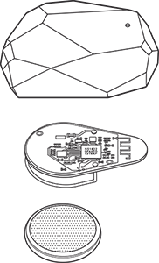

BROADCASTING RANGE AND PROXIMITY
You can think about the beacon as a small lighthouse tower that's installed in a fixed location and broadcasts its presence to all the ships (smartphones) around. They could be as little as 2 inches and as far as 230 feet (approx. 70 metres) away.

The exact maximum range depends on the environment of course. Bluetooth is using the same type of radiowaves as 2.4Ghz WiFi routers. The signal can be diffracted, interferred or absorbed by water (including the human body).
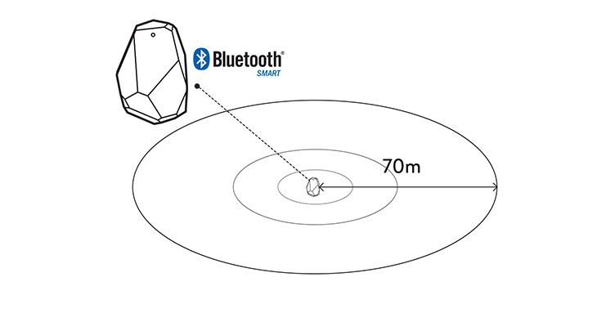
Phones or other smart devices in the range can pickup the Bluetooth radio signal (without previous pairing) and estimate their distance to the beacon by measuring the received signal strength (RSSI). The closer you are to the beacon, the stronger the signal is. Depending on implemention, devices could probe the signal every second (1 Hz) or 10 times a second (10 Hz). The more often it's done, the more stable signal and the more responsive application is, and the better customer experience can be achieved.

UNIQUE IDENTIFIERS
Smartphone can pick up signal from more than one beacon at the same time. If there are three or more beacons within range, your phone can calculate the distance to each beacon and use this data to estimate its relative location. This technique is something that sailors had used for ages. They were navigating thanks to unique fixed markers like lighthouses or stars.

Estimote Beacons can be uniquely identified as well since each beacon broadcasts its own ID.
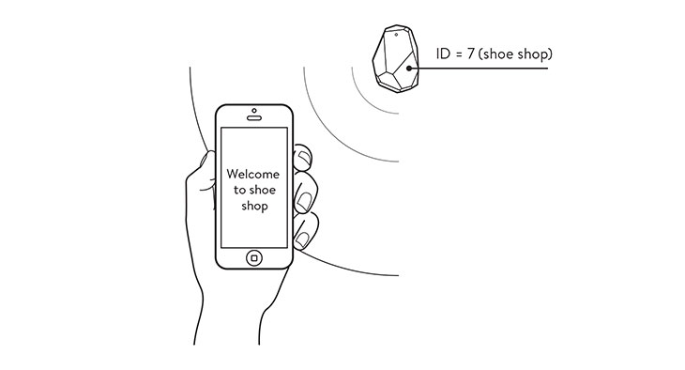
Every ID is 20 bytes long and is divided into three sections: proximityUUID (16 bytes) + major number (2 bytes) + minor number (2 bytes).
Here is an ID example: c2d360a002a601315add1040f3913c300102 - think about it as an IP number of each device. In order to discover all Bluetooth beacons in the range and check their IDs you can use popular BLE scanners like BLExplr app available in the App Store.You could also do it programatically, which will be explained in the later part of API documentation).

CONTEXT AND MICRO-LOCATION FROM THE CLOUD
Once you get an ID and the distance (RSSI) to the beacon you get micro-location and context.

You could now take detected ID and depending on the distance display different actions on user's phone.

Since beacons broadcast only tiny amount of information you have to fetch relevant content (e.g. picture of a shoe) from your local database or cloud-based storage.
Don't worry - you don't have to build your own back-end to handle that - you'll be able to use our own fleet and context management system that will be announced with extended API soon.
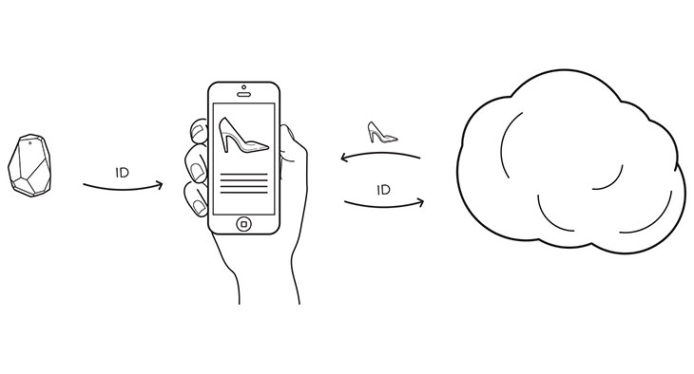

GEOFENCING
Now is the magic part. Apps can subscribe in the operating system (both iOS and Android) to constantly listen for particular identifiers. When the phone comes into the range of a beacon, the app is notified about this, even if the phone is locked or the app is not currently running.

MONITORING DISTANCE AND TRIGGERING EVENTS
Additionally the smart phone is continuously monitoring the strength of the signal (or RSSI), which is compared to three predefined ranges that divide the area around a beacon into three zones - far, near and immediate. The application is also notified which zone the phone is currently in. Whenever the user enters a zone, their context may change, so the OS notifies the application about this event as well.

4.2 BACKEND
INTRODUCTION TO DATABASE
Any programming environment used to create containers, to manage human data, in the conceptualization as a Data Management System. Traditionally, the block of human data being managed is called a Database. Hence, in very simple terms, these programming environments can the conceptualized as Database Management Systems, in short DBM systems.

ORACLE
The oracle database (commonly referred to as oracle RDMS or simply Oracle) consists of a relational database management system (RDBMS) produced and marketed by Oracle corporation. As of 2008, Oracle had become a major presence in database computing.

Larry Ellison and his friends and former co-workers Bob miner and Ed Oates started the consultancy software Development Laboratories (SDL) in 1997.SDL development the original version of the Oracle software. The name Oracle comes from the code-name of a CIT-funded project Ellison had Worked on while previously employed by Ampex.

Why Oracle 10G?
Oracle Database 10g is the first database designed for grid computing, the most flexible and cost-effective way to manage enterprise information. It cuts costs of management while providing the highest possible quality of service.

In addition to providing numerous quality and performance enhancements, Oracle Database 10g significantly reduces the costs of managing the IT environment, with a simplified install, greatly reduced configuration and management, requirement, and automatic performance diagnosis and SQL statement tuning. These and other automated management capabilities help improve DBA and Developer productivity and efficiently.

End User Correction
An Oracle 10g database provides support for Flashback Query. We can generate Flashback information within a SQL statement instead of just within a session. You can restore deleted rows, old values and pervious version of the table. You can also select difference between two times.

Data Integration
Oracle 10g has an information sharing feature, Oracle Streams. Oracle Streams enables the propagation of data, transaction and events in a data stream either with in a database or from one database to another. Users can use Streams to replicate the data, implement message queuing and management, load changes data into data warehouse, send notification of database events to subscribers, and provide high availability solutions to protect data.

Simply Administration
In Oracle 10g we have a provision of simplifying the operational management of the database; the system table space can also be locally managed. This means that all the table space in the database can be created as locally managed, thus simplifying the database administrator’s task.

Eliminate Complexity
Performance tuning is made simpler with intelligent tuning features in Oracle 10g.This provides actual operation-level query execution statistics, as opposed to estimated statistics. This helps identify the most expensive SQL statement and their corresponding operations. It is now easier to identify tables, partitions and indexes that are heavily accessed. Using these new statistics, one can new set of “Top-Object” charts. These charts allow the data base administrator to see easily which objects are more heavily accessed and further simplifies the diagnosis of performance problems.

Security
With the help of Oracle10g now a user id/password can be provided on a create database statement and a number of default accounts are locked and expired upon installation, providing additional security. Additionally Oracle 10g enhances two security options i.e. Oracle label securities supports data reliabilities in data labels and provide more sophisticated methods of controlling dissemination of data.

Eclipse
Eclipse is an open-source community that develops open platforms and products. The community says its projects “are focused on building an open development platform consisting of extensible frameworks, tools and runtimes for building, deploying and managing software across the lifecycle”. The Eclipse Foundation is a non-profit corporation which acts as the steward of the Eclipse community.

However, as the Eclipse community states.”Eclipse means a lot of different things to different people. To some Eclipse is a java development environment. To others, Eclipse is a flexible environment to experiment with new computer languages or extensions to existing languages. In the software world, a simple mention of “Eclipse” usually refers to the Eclipse Software Development Kit (SDK).The Eclipse SDK consists of the Eclipse platform, java development tools and the plug-in Development Environment. The Eclipse platform is a multi-language software development environment comprising an integrated development environment (IDE) and an extensible plus-in system. It is written mostly in java. By means of various plug-in, it can be used to develop applications in various

Programming languages including Ada, C, C++, COBOL, Java, Perl, PHP, Python, Ruby, Scala, Clojure, Groovy and Scheme. It can also be used to develop packages for the software Mathematical. Development environments include the Eclipse Java development tools (JDT) for java, Eclipse CDT for C/C++ and Eclipse PDT for PHP, among others. The initial codebase originated from Visual Age. The Eclipse SDK (Which includes the java development tools) is meant for java developers. Users can extend its abilities by installing plug-in written for the Eclipse Platform, such as development toolkits for other programming languages, and can write and contribute their own plug-in modules.

Rational Rose
The Rational Rose Family of products is a set of UML modeling tools for software design. The Unified Modeling Languages (UML) is the industry-standard language for specifying, visualizing, constructing and documenting the artifacts of software systems. It simplifies the complex process of software design, creating a “blueprint” for construction of software systems.

The IBM Rational Rose family is for customers wishing to integrate with legacy integrated development environments or languages. For more modern architectures IBM Rational software Architect and IBM Rational Software Modeler were development. These products were created matching and surpassing Rose XDE capabilities to include support for UML 2.x,pattern customization support, the latest programming languages and approaches to software development such as SOA and more powerful data modeling that supports Entity-Relationship modeling.

5. SYSTEM DESIGN
5.1 INTRODUCTION
Design is the first step in the development phase for any engineering product or System. It may be defined as a “the process of applying various techniques and principles for the purpose of defining a device, a process, or a system insufficient detail to permit its physical realization”. Software design is an iterative process through which requirements are translated into a “blue print” for the constructing software. The design is represented at high level of abstraction, a level that can be directly translated to a specific data, functional behavior requirements. Preliminary design is concerned the transformation of requirements into a data and software architecture.

The design is solution, a “how to” approach to the creation of a new system. This is composed of several steps. It provides the understanding and procedural details necessary for implementing the system recommended. The database design transforms the information domain model created during analysis into the data structures that will be required to implemented software.

The architecture design describes how the software communicates within itself, to the systems that interoperate with it, and with humans who use it. An interface implements flow of information. The interface design describes how the software communicates within itself, to systems that interoperate with it, and with humans who use it. An interface implements flow of information

5.2 Design Principles
Basic design principles that enable the software engineer to navigate the design process are
- The design should be traceable to analysis model
- The design should not reinvent the wheel
- The design should minimize the intellectual distance between the software and the problem as it exists in the real world
- The design should exhibit uniformity and integrity
- The design should be structured to accommodate changes
- The design should be reviewed to minimize the conceptual errors

5.3 UML DIAGRAMS
Design is the first step in the development phase for an engineered product or system. Design id the place where quality is fostered in software Development. Design is the only way that can accurately translate a user’s requirements into a finishes software product or system. Software design serves as the foundation for all software engineers and software maintenance steps that follow. Without design we risk building an unstable design-one that will fail when small changes are made, one that may be difficult to test, and one whose quantity cannot be accesses until late in the software engineering process.

Taking software requirements specification document of analysis phase as input to the design phase we have drawn Unified Modeling of the system. Visual modeling is the process of taking the information from the model and displaying it graphically using some sort of standards set of graphical elements.

TYPES OF UML DIAGRAMS
Each UML diagram is designed to let developers and customers view a software system from a different perspective and in varying degrees of abstraction. UML diagrams commonly created in visual modeling tools include.

5.3.1 USE CASE MODEL:
USE CASE DIAGRAM FOR THE ENTIRE SYSTEM

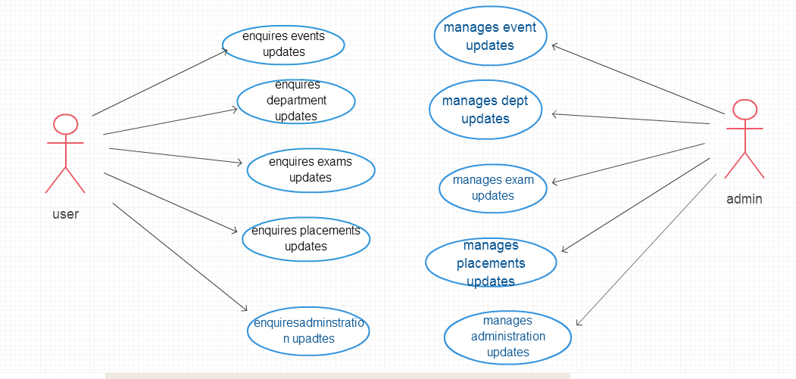

5.3.2 SEQUENCE DIAGRAMS
SEQUENCE DIAGRAM FOR THE ENTIRE SYSTEM:

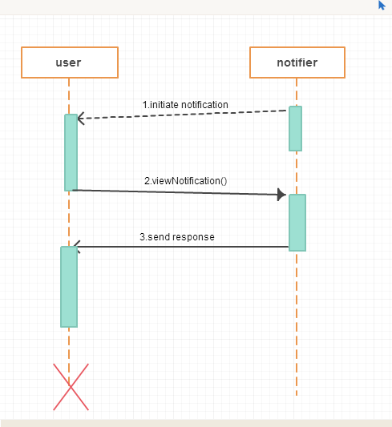

5.3.3 COLLABORATION DIAGRAMS

COLLABORATION DIAGRAM FOR THE ENTIRE SYSTEM:
Figure 5.4: Collaboration Diagram for the entire system

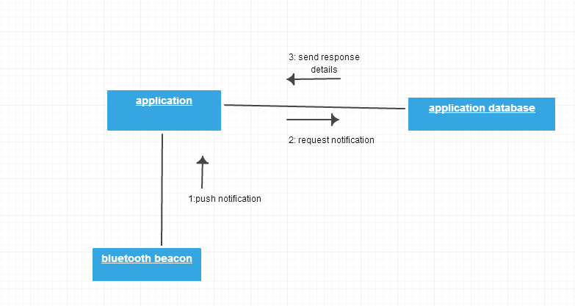

5.4 Class Diagram
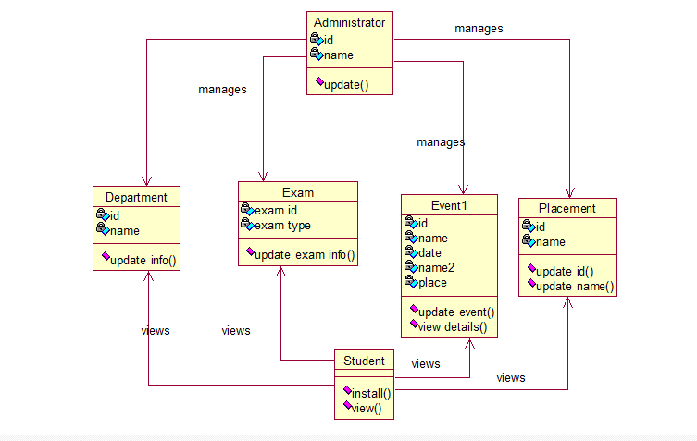

5.5 E-R Model

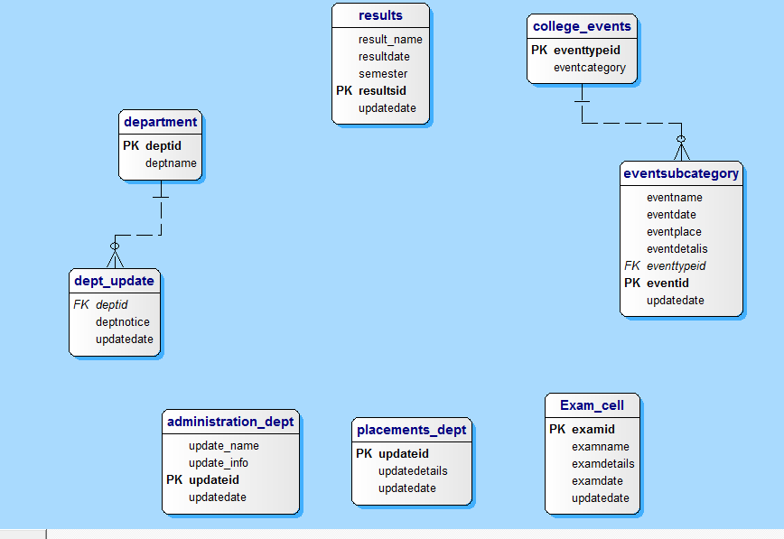

5.5 DATABASE DESIGN
Number of Database Tables
The project has been identified to contain 8 database tables, which are as follows

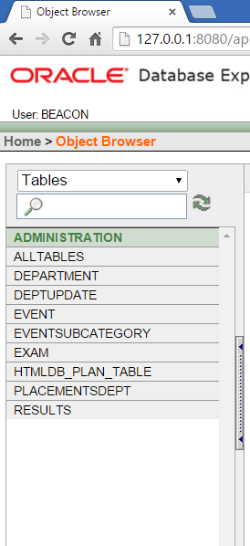

Table Name: ADMINISTRATION

EDIT | UPDATE_NAME | UPDATE_INFO | UPDATEID | UPDATEDATE
 | Scholarship details | Last date for submitting doc | 1 | 18-MAR-15
 | 4-1 supple notification | last date 25/march/2015 | 3 | 18-MAR-15
 | 4-2 sem fees | last date for fee payment | 2 | 18-MAR-15

Table Name: DEPARTMENT
EDIT | DEPTID | DEPTNAME
 | 2 | CSE
 | 1 | ECE
 | 4 | MECH
 | 6 | IT
 | 3 | EEE
 | 5 | CIVIL

Table Name: DEPTUPDATE
EDIT | DEPTUPDATEID | DEPTID | DEPTNOTICE | UPDATEDATE
 | 4 | 4 | MECHANICAL FINAL PROJECT REVIEW IS ON 27 MARCH 2015 | 18-MAR-15
 | 9 | 3 | EEE PROJECT DOCUMENTATION SUBMISSION AT EEE PRESENTATION LAB ON 5 APRIL 2015 | 25-APR-15
 | 13 | 1 | ECE SECOND MID EXAM STARTS FROM 30 MARCH 2015 | 25-MAR-15
 | 14 | 2 | CSE SECOND MID EXAM STARTS FROM 30 MARCH 2015 | 25-MAR-15
 | 18 | 6 | IT SECOND MID EXAM STARTS FROM 30 MARCH 2015 | 25-MAR-15
 | 3 | 3 | EEE FINAL PROJECT REVIEW IS ON 26 MARCH 2015 | 18-MAR-15
 | 7 | 1 | ECE PROJECT DOCUMENTATION SUBMISSION ON 4 APRIL 2015 | 25-MAR-15
 | 8 | 2 | CSE FINAL PROJECT DOCUMENTATION SUBMISSION HELD AT PRESENTATION HALL ON 4 APRIL 2015 | 25-MAR-15
 | 10 | 4 | MECHANICAL FINAL PROJECT DOCUMENTATION SUBMISSION AT MECH BLOCK ON 6 APRIL 2015 | 25-MAR-15
 | 11 | 6 | IT FINAL PROJECT DOCUMENTATION SUBMISSION AT PRESENTATION HALL ON 6 APRIL 2015 | 25-MAR-15
 | 12 | 6 | IT FINAL PROJECT REVIEW AT PRESENTATION HALL ON 18 MARCH 2015 | 12-MAR-15

Table Name: EVENT
EDIT | EVENTTYPEID | EVENTCATEGORY
 | 1 | TECHNICAL
 | 2 | CULTURAL

Table Name: EVENTSUBCATEGORY
EDIT | EVENTID | EVENTNAME | EVENTDATE | EVENTPLACE | EVENTDETALIS | EVENTTYPEID | UPDATEDATE
 | 1 | FRESHERS DAY | 21-MAR-15 | INDOOR AUDITORIUM | FRESHERS DAY CELEBRATIONS FOR FIRST YEAR STUDENTS AT INDOOR AUDITORIUM | 2 | 13-MAR-15
 | 6 | ANDROID WORKSHOP | 26-MAR-15 | VIRTUSA SKILLS CENTER | WORKSHOP ON ANDROID FOR ALL BRANCHES AT VIRTUSA SKILLS CENTER | 1 | 18-MAR-15
 | 2 | ANNUAL DAYS CELEBRATIONS | 19-MAR-15 | VISHNU OUTDOOR AUDITORIUM | 7 TH ANNUAL DAY CELEBRATIONS OF VISHNU INSTITUTE OF TECHNOLOGY | 2 | 13-MAR-15
 | 4 | PAPER PRESENTATIONS | 23-MAR-15 | VISHNU SKILLS CENTER | PAPER PRESENTATIONS ON SOFT AND CORE SKILLS FOR ALL BRANCHES | 1 | 13-MAR-15
 | 7 | POWER POINT PRESENTATIONS | 25-MAR-15 | VISHNU SKILLS CENTER | POWER POINT PRESENTATIONS ON BIGDATA AND CLOUD COMPUTING | 1 | 25-MAR-15
 | 8 | POWER POINT PRESENTATIONS | 26-MAR-15 | PRESENTATIONS HALL | POWER POINT PRESENTATIONS ON DATA MINING AND DATA WAREHOUSE | 1 | 24-MAR-15
 | 9 | CODE QUIZ | 28-MAR-15 | SOFTWARE LAB | CODE QUIZ FOR COMPUTER SCIENCE STUDENTS | 1 | 20-MAR-15
 | 3 | DANCE FEST | 20-MAR-15 | SVECW AUDITORIUM | DANCE COMPETITIONS BETWEEN SVECW AND VIT AT SVECW AUDITORIUM | 2 | 13-MAR-15

6. SAMPLE CODE

package com.Display:-

import org.json.JSONArray;
import org.json.JSONException;

import android.app.Activity;
import android.os.Bundle;
import android.widget.ArrayAdapter;
import android.widget.ListView;

public class Administration extends Activity{
ListView ls;
String request,response;
static String[] update_id;
static String[] update_name;
static String[] update_info;
static String[] update_date;
public void onCreate(Bundle savedInstanceState) {
super.onCreate(savedInstanceState);
setContentView(R.layout.adminstration_layout);

ls=(ListView)findViewById(R.id.listViewAdmin);
/*name=(TextView) findViewById(R.id.name);
date=(TextView)findViewById(R.id.date);
place=(TextView)findViewById(R.id.place);
details=(TextView)findViewById(R.id.details);*/

request=ConnectionUtil.url+"sample?action=administration";
response=ConnectionUtil.getConnection(request);

JSONArray subarr;
try{
subarr = new JSONArray(response);
update_id=new String[subarr.length()];
update_name=new String[subarr.length()];
update_info=new String[subarr.length()];
update_date = new String[subarr.length()];
for(int i=0;i<subarr.length();i++){
update_id[i]=subarr.getJSONObject(i).optString("id");
update_name[i]=subarr.getJSONObject(i).optString("name");
update_info[i]=subarr.getJSONObject(i).optString("info");
update_date[i]=subarr.getJSONObject(i).optString("date");

//name=setText(event_name[i]);
/*System.out.println(event_name[i]);
System.out.println(event_name[i]);
System.out.println(event_date[i]);
System.out.println(event_details[i]);
System.out.println(event_place[i]);*/
}
System.out.println(update_name);
//ArrayAdapter<String> adapterlistview=new ArrayAdapter<String>(Administration.this, android.R.layout.simple_list_item_1,update_name);
AdminAdapter edp = new AdminAdapter(Administration.this, update_name, update_info, update_id, update_date);
ls.setAdapter(edp);
} catch (JSONException e) {
// TODO Auto-generated catch block
e.printStackTrace();
}
}
}

7. TESTING
7.1 INTRODUCTION
Software testing is a critical element of software quality assurance and represents the ultimate review of specification, design and coding. The increasing visibility of software as a system element and attendant costs associated with a software failure and motivating factors for we planned, through testing. Testing is the process of executing a program with the intent of finding an error. The design of tests for software and other engineered products can be as challenging as the initial design of the product itself.

7.2 TESTING STRATEGIES
Testing is a set of activities that can be planned in advanced and conducted systematically

UNIT TESTING
Unit testing involves the design of test cases that validate that the internal program logic is functioning properly, and that program inputs produce valid outputs.

INTEGRATION TESTING
Integration tests are designed to test integrated software components to determine if they actually run as one program.

SYSTEM TESTING

System testing ensures that the entire integrated software system meets requirements.

WHITE BOX TESTING
White Box Testing is a testing in which in which the software tester has knowledge of the inner workings, structure and language of the software, or at least its purpose. It is purpose. It is used to test areas that cannot be reached from a black box level.

BLACK BOX TESTING
Black Box Testing is testing the software without any knowledge of the inner workings, structure or language of the module being tested

TEST OBJECTIVES
- All field entries must work properly.
- Pages must be activated from the identified link.
- The entry screen, messages and responses must not be delayed.

FEATURES TO BE TESTED
- Verify that the entries are of the correct format
- No duplicate entries should be allowed
- All links should take the user to the correct page.

INTEGRATION TESTING
Software integration testing is the incremental integration testing of two or more integrated software components on a single platform to produce failures caused by interface defects.

The task of the integration test is to check that components or software applications, e.g. components in a software system or – one step up – software applications at the company level – interact without error.

ACCEPTANCE TESTING
User Acceptance Testing is a critical phase of any project and requires significant participation by the end user. It also ensures that the system meets the functional requirements.

7.3 TEST REPORT
Test. C.No | Input | Expected  Behavior | Observed Behavior | Status  P=Passed  F=Failed
1. | When device comes into the range. | Receive the notification in the notification bar. | Notification received. Shows the beacon MAC address and notification name. | P
2. | Click the notification. | Displays the notification details | Displays the notification details. | P
3. | Select one from drop down menu. | It should prompt all the information about the required query | All the respective selected item results were displayed. | P
Table: 7.3: Test Reports

8. SCREEN SHOTS

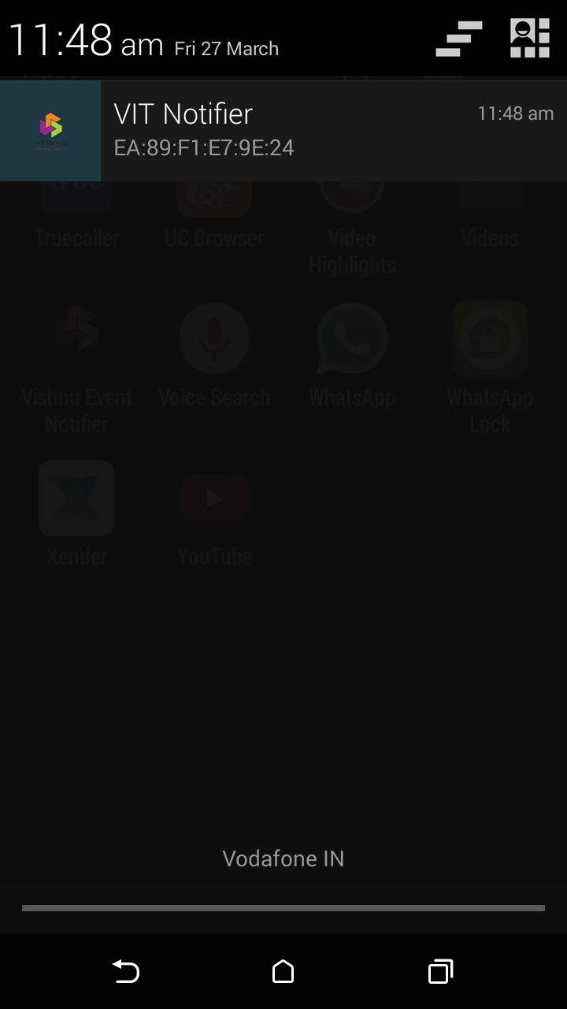
Figure 8.1: Notification bar

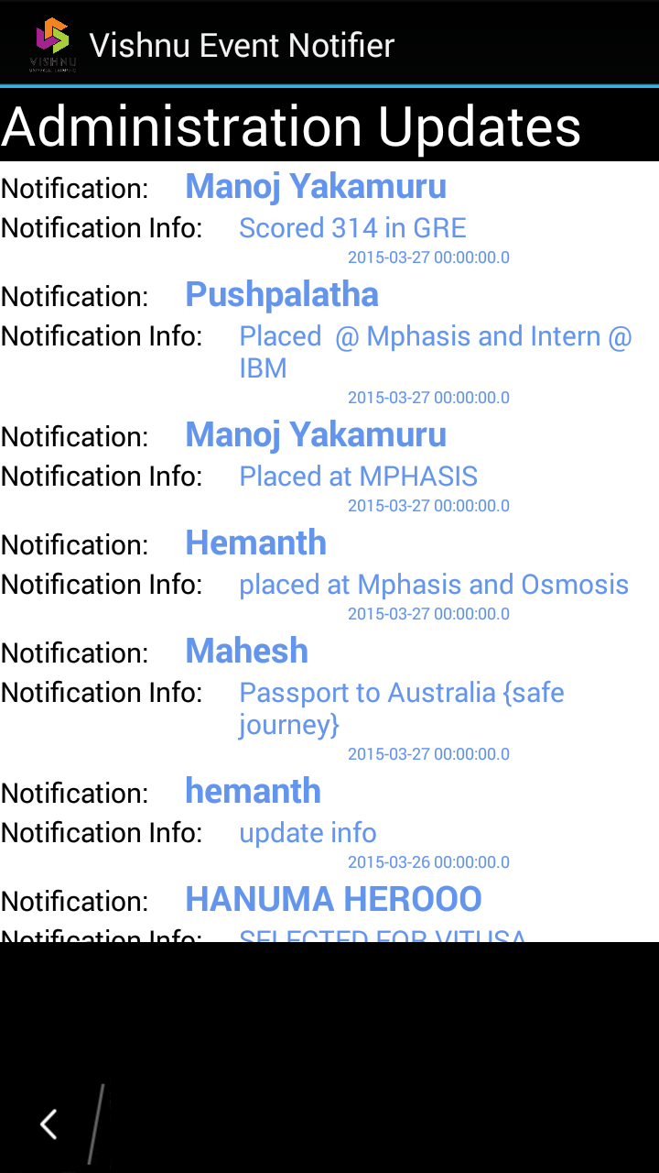
Figure 8.2: Display details page.

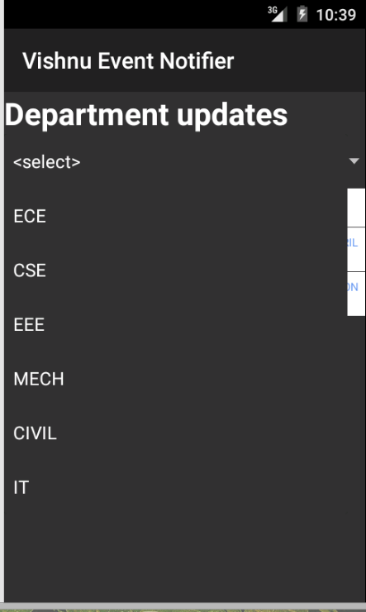
Figure 8.3: Department updates.

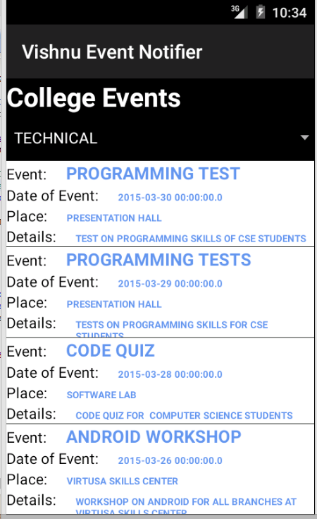
Figure 8.3: events(technical events) updates.

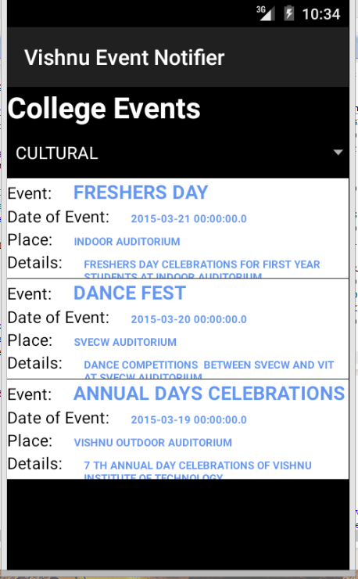

Figure 8.3: events(cultural events) updates.

9. CONCLUSION

The project has been successfully implemented with all the features mentioned in the SRS. This project to a huge extent simplifies the process knowing the notification and latest updates in the college. This “Notification system” achieves the student and also faculty satisfaction. We can receive the notification faster. Information about the updates can be provided to the students at any time and this system that we developed is more accurate and unique.

FUTURE ENHANCEMENTS
We can provide outbound facility to this project. In this project we are only proving the notification through the Bluetooth beacon, in future we can enhance it by make it so interactive and form a discussion forum, we can integrate the application with student faculty interaction with help of login and session maintenance. It would be so real and interactive. Google could messaging would be useful for messaging and authentication through google APIs.

10. BIBLIOGRAPHY

Textbook References:
- Herbert Scheldt, The complete reference JAVA2, 5th edition, Tata McGraw Hill Publisher Company limited, 2002.
- George Koch, Kevin loney, ORACLE, The complete reference, 3rd edition, Tata McGraw-Hill Publisher Company limited, 1997.
- Ivan Bayross, SQL, PL/SQL the programming Language of Oracle, 2nd edition, BPB Publications, 2002.

Web References:

- http://www.developers.android.com
- www.bluetoothbeacons.com
- http://www.w3schools.com
- http://java.sun.com
- http://www.w3.org
- http://www.javatpoint.com

